- We think improving profitability and falling interest rates will underpin a gradual pickup in UK business investment. But this follows a decade over which capital spending has flatlined and even if our forecast proves accurate, it would still leave the UK well behind peers like the US.
- The weak post-pandemic recovery so far is largely due to a shortage of internal finance and a sharp increase in borrowing costs. Investment in buildings has been particularly weak, with changing working patterns compounding the impact of higher raw material costs and interest rates.
- Still, the experience of the recent hiking cycle suggests cuts to policy rates will pass through quickly to corporate interest rates. Meanwhile, small firms have deleveraged significantly after a sharp rise in debt levels during the pandemic, and are now in better shape to borrow again.
- But corporate sentiment is fragile. There's an onus on the government to deliver a more stable political backdrop that could give firms the confidence to commit to projects.
The UK is at the start of a rate-cutting cycle. One part of the economy that stands to benefit most is business investment, as capital spending tends to be highly sensitive to interest rate changes. For many companies, the recent environment has been even more challenging because of the additional debt they took on to get through the pandemic. But small firms have deleveraged significantly, and debt servicing costs should now start to drift downwards. So we think business investment is poised to begin a gradual recovery (Chart 1).
Since the global financial crisis, the UK's business investment performance has been poor. As of 2023, the level of the non-residential capital stock per hour worked was 23% below the level it would have been had the 1990-2008 trend continued. Low levels of business investment are also a key factor behind fixed investment consistently accounting for a lower share of GDP in the UK than in any other G7 country over the past 20 years.
Chart 1: We expect a gradual pickup in capital spending as debt servicing costs fall
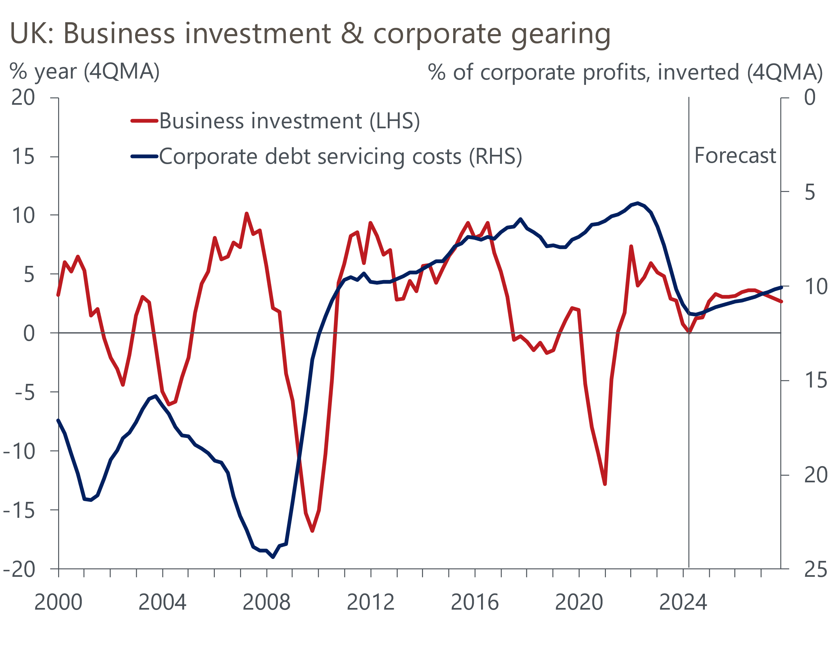
Sources: Oxford Economics, Haver Analytics

Business investment is currently no higher than it was in 2016
Business investment fell by 25% in the global financial crisis. It wasn't until H2 2014 that capital spending returned to its previous peak, despite debt servicing costs dropping to very low levels. The cost of borrowing remained low, but capital spending then flatlined, undermined by weak demand and Brexit.
Investment fell by more than 20% again during the Covid pandemic. Until recently, the post-pandemic recovery had looked impressive, with capital spending reported to have regained its pre-pandemic peak in just over two years, rising more than 5% above its end-2019 level in H2 2024. But the latest set of data revisions, consistent with the 2024 Blue Book, show a much weaker trend, with business investment having only just regained its pre-pandemic level (Chart 2). Indeed, considering the poor performance before the pandemic, capital spending is still at the same level now as in 2016.
Chart 2: After large data revisions, business investment is still the same level it was in 2016
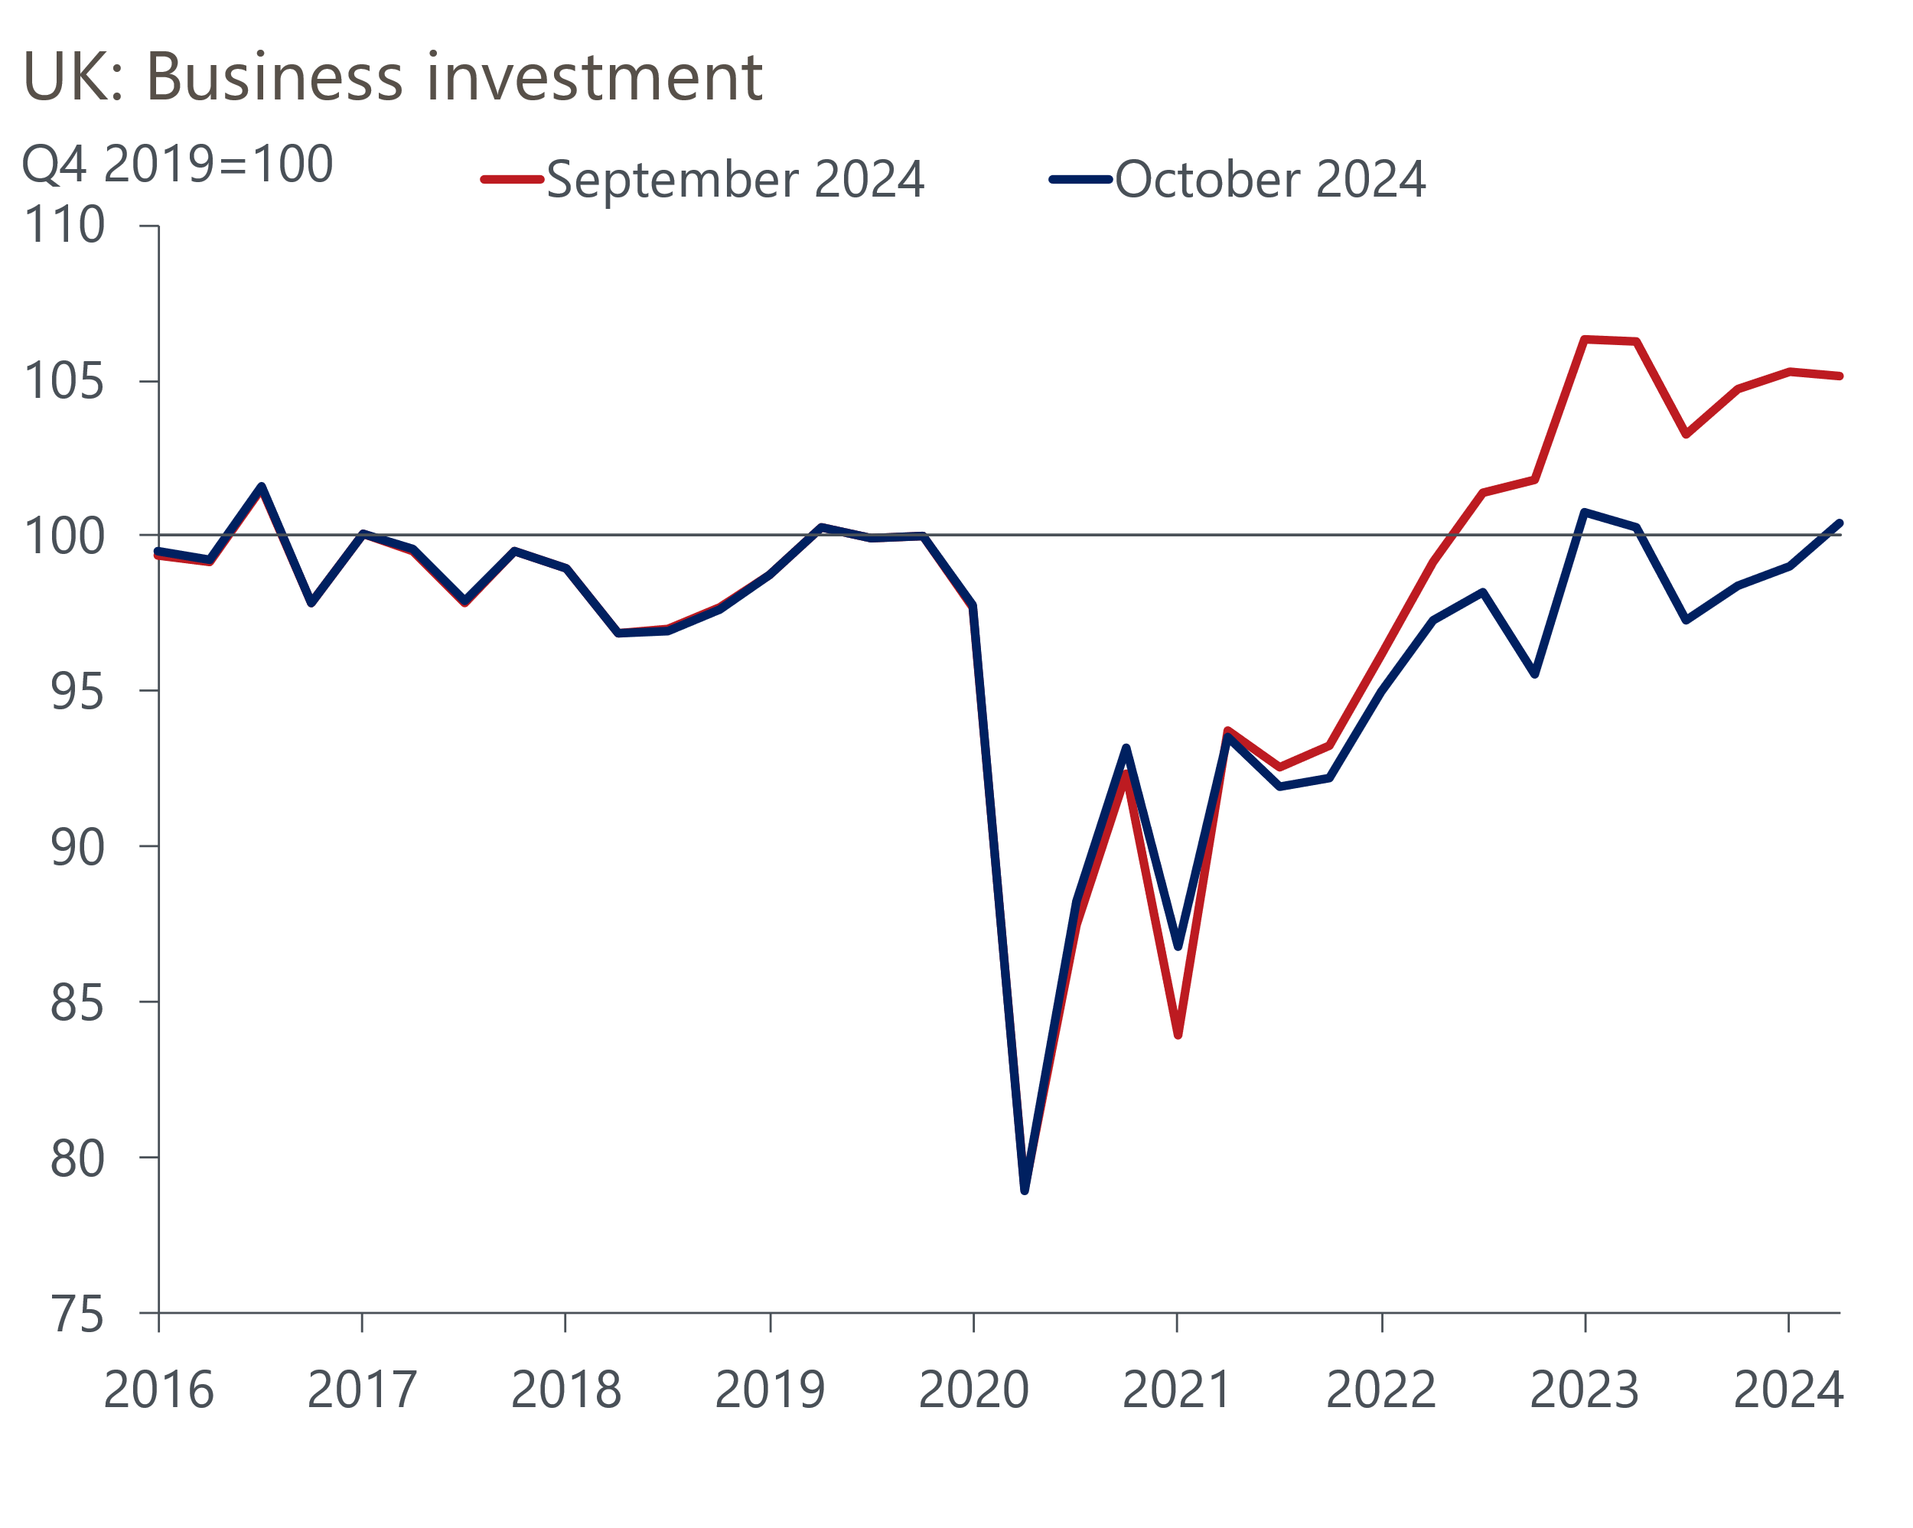
Source: Oxford Economics calculations using data from Haver Analytics
The breakdown by asset type shows a sharp drop in investment in buildings and structures is the main reason for the weakness since 2016 (Chart 3). Spending on buildings slumped in the early stages of the pandemic and has remained at similar levels since. Two factors underpin this weakness. First, the increase in hybrid working and resulting rise in office vacancy rates has reduced the incentive for developers to take on new projects. Second, financial pressures from surging raw material prices and high interest rates have undermined the viability of commercial real estate developments.
Chart 3: Falling spending on buildings has been the main cause of the stagnation in business investment
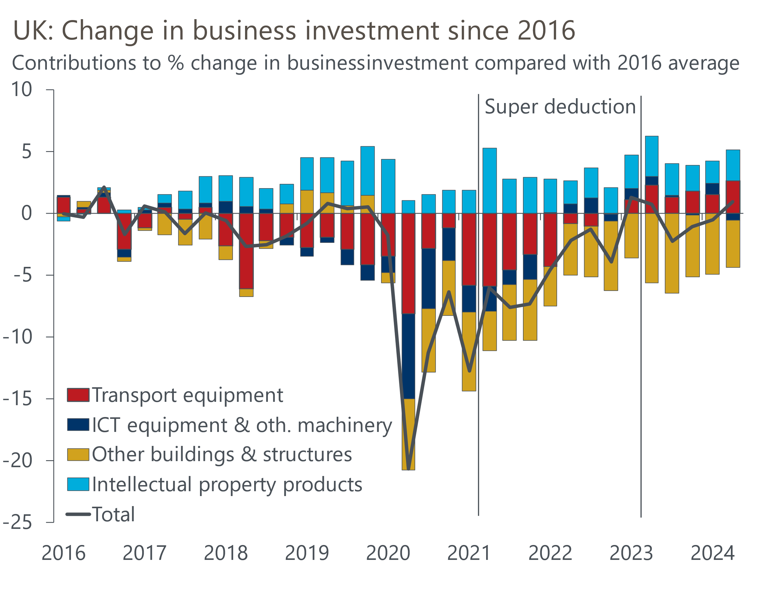
Source: Oxford Economics calculations using data from Haver Analytics
Growth in spending on other assets hasn't been particularly strong either. Investment in transport equipment collapsed during the pandemic, due to the impact of the slump in tourism on demand for aircraft. That fall has subsequently fully reversed, although momentum has ebbed in recent quarters now that pent-up demand has been fulfilled. There's some evidence that the super-deduction – a temporary 130% capital allowance for investment in plant and machinery available from Q2 2021 to Q1 2023 – helped to support the post-pandemic recovery in ICT equipment. But the relatively narrow focus of the scheme meant that it was a small piece of the story for business investment in aggregate.

Financial constraints are the main factor behind the recent low levels of investment
The latest CBI surveys identify financial factors as far more important constraints on investment now than in the past (Chart 4). Other data back that idea: over the last year, the ratio of corporate profits to GDP has dropped to its lowest level since the global financial crisis.
Chart 4: Finance-related factors are more important constraints on investment now than historically
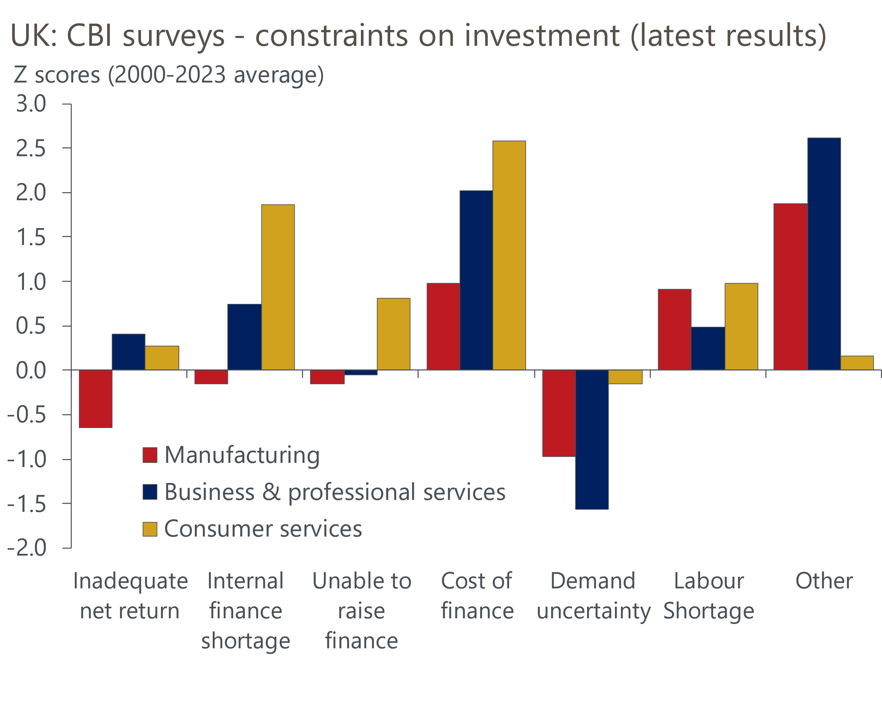
Source: Oxford Economics calculations using data from Haver Analytics
Meanwhile, the level of corporate deposits has fallen sharply over the past two years. Like households, companies built up substantial 'excess savings' during the pandemic – by mid-2022, the level of corporate deposits was £119bn (4.8% of GDP) higher than it would have been had the 2016-2019 trend continued (Chart 5). But since then, most of the stock of excess savings has been unwound, reducing the amount of internal funding available to finance capital spending.
Chart 5: Most of the 'excess savings' built up by companies during the pandemic has been eroded
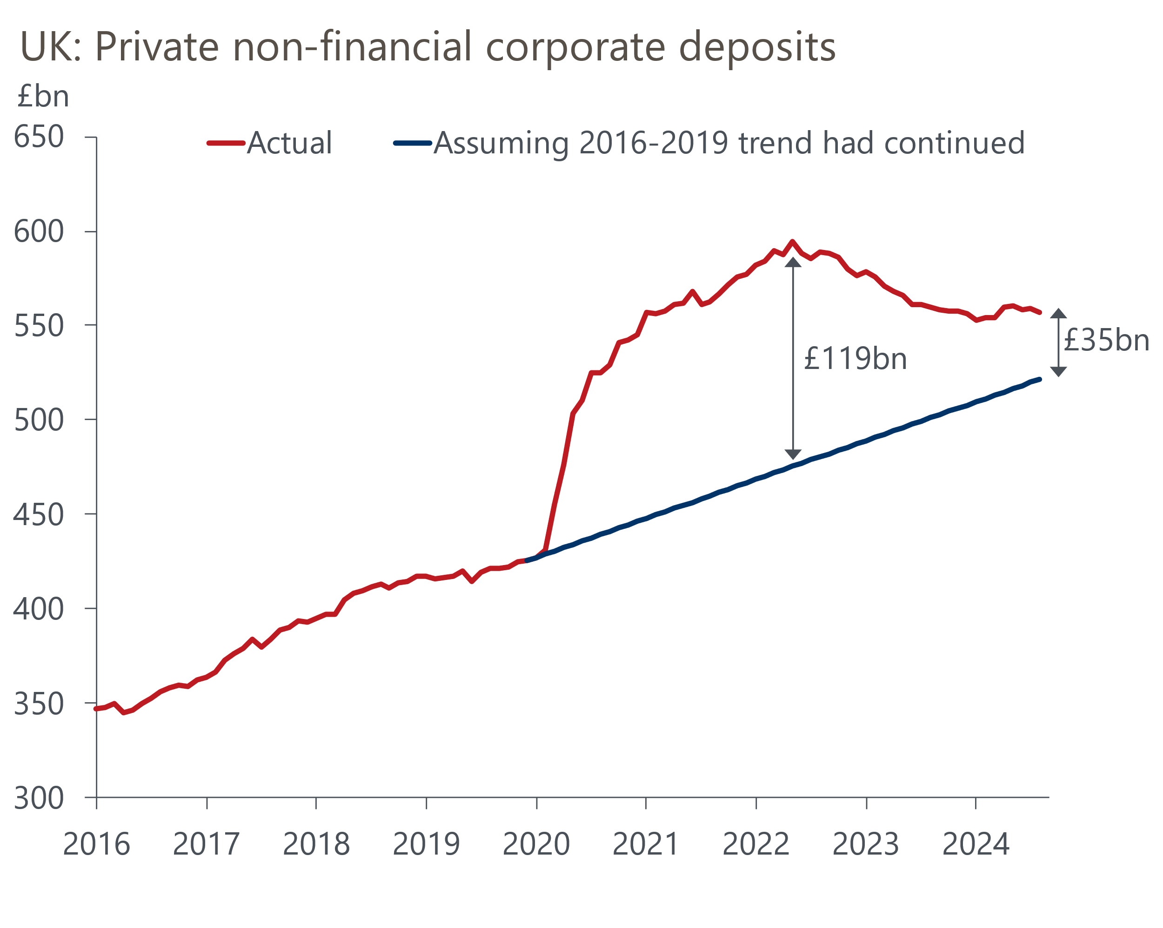
Source: Oxford Economics calculations using data from Haver Analytics
Rising debt servicing costs have been a key pressure on corporate finances. The average interest rate on outstanding loans to companies rose by more than 400bps during the Bank of England's hiking cycle – more than double the increase in average household mortgage rates (Chart 6). What's more, the pass through was rapid, with the bulk of the rise in corporate interest rates happening during the period when the BoE was increasing the policy rate. Most corporate debt is floating rate or fixed at short maturities, and hence resets quickly in response to changes in Bank Rate.
Chart 6: Corporate interest rates responded quickly to rising Bank Rate
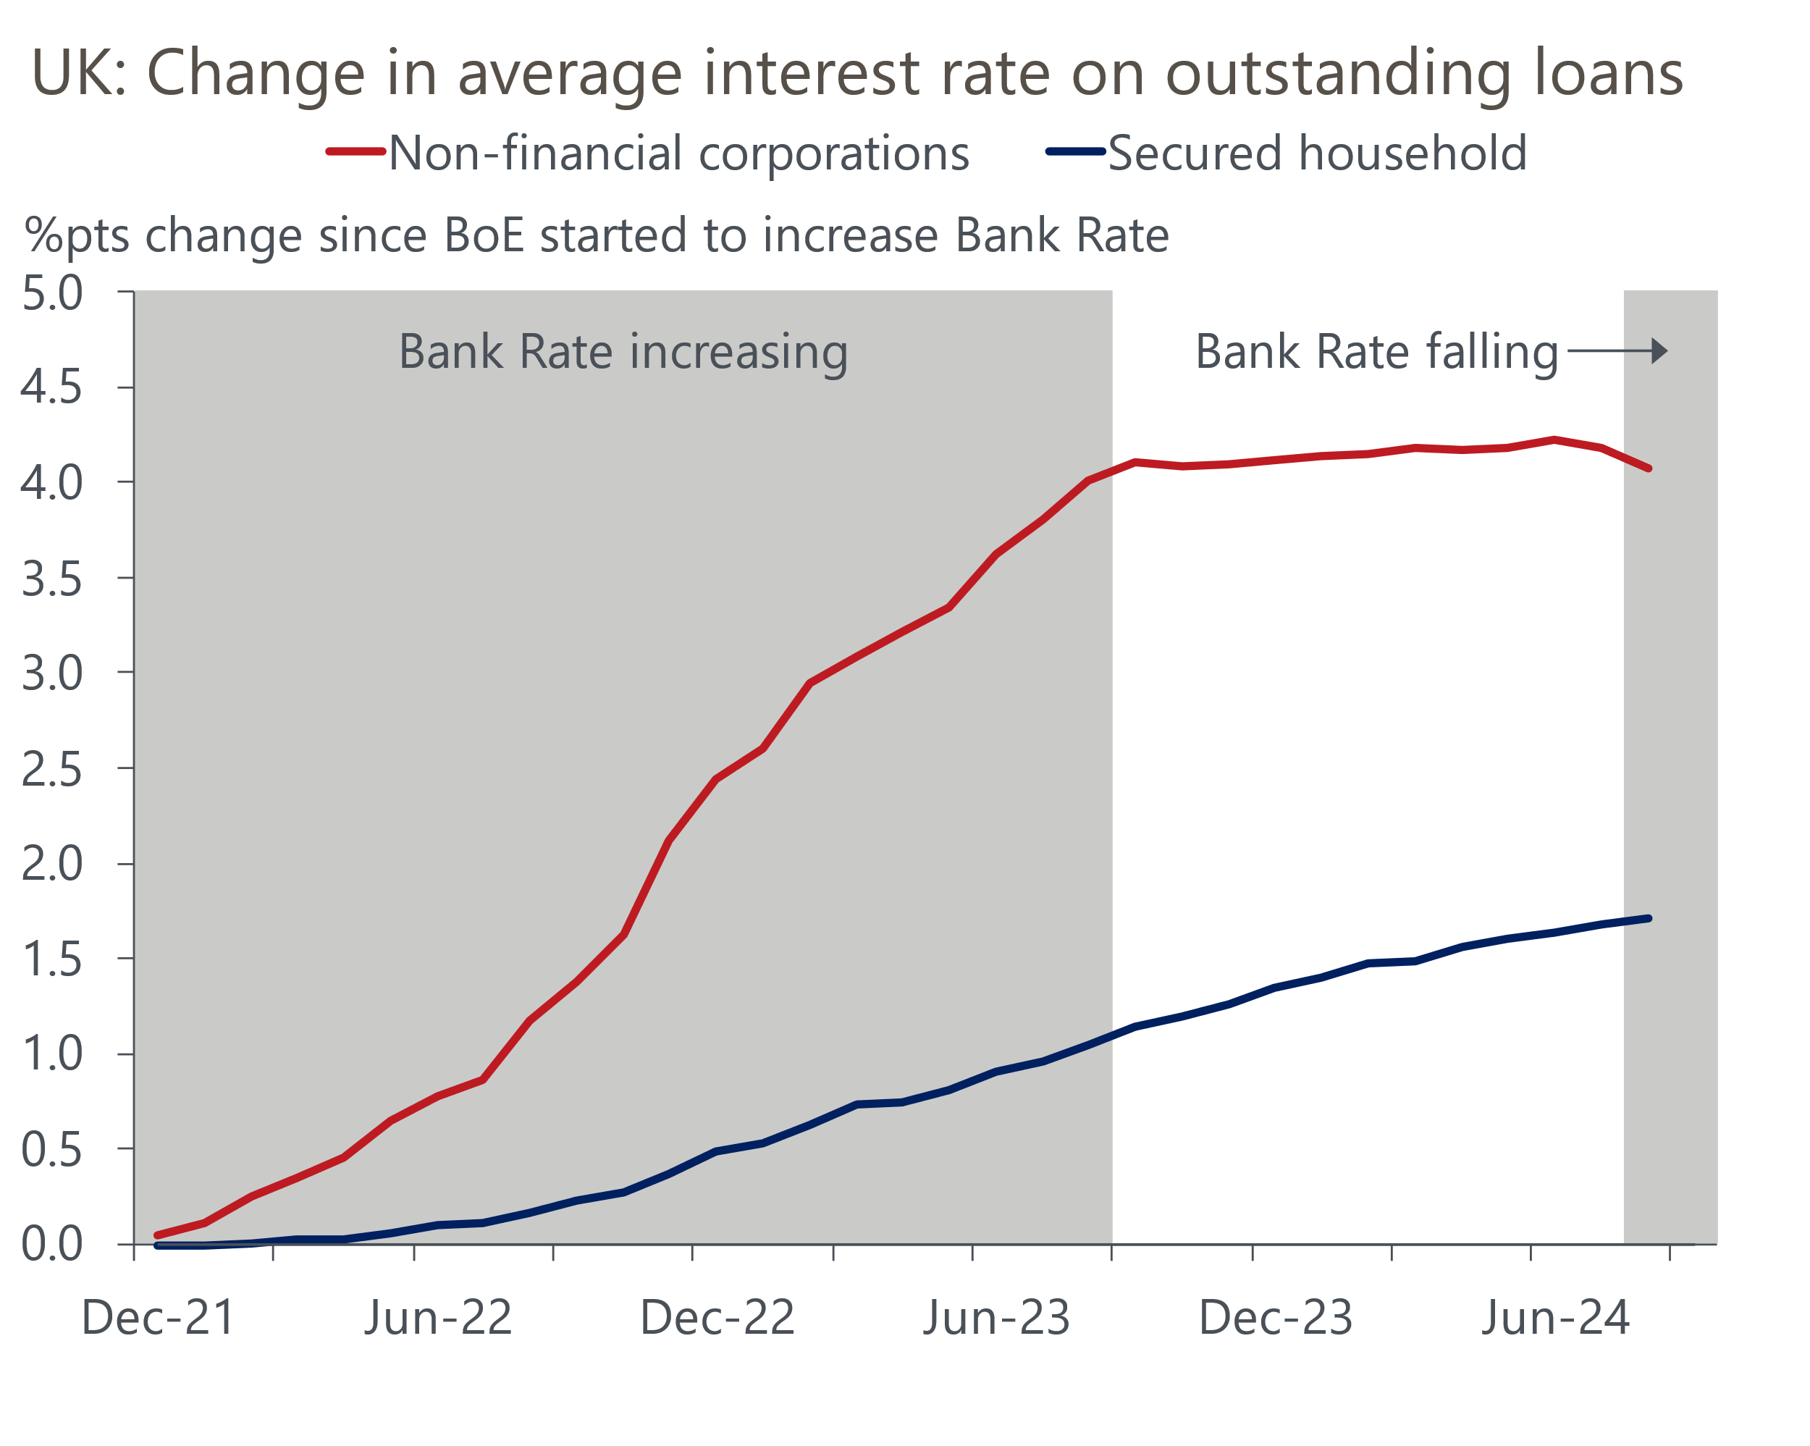
Source: Haver Analytics
Small and medium-sized enterprises were particularly vulnerable to the impact of rising interest rates because of the extent to which their debt levels rose during the pandemic. In 2020, the stock of outstanding loans to SMEs rose by more than 30%, in marked contrast to loans to larger firms. Some of the new debt came from loans backed by the state, which carried fixed interest rates. Still, in early-2024, debt servicing costs as a share of corporate profits were at their highest level for 14 years (Chart 1).

The financial outlook for companies is brightening
We think the worst has now passed for debt servicing costs. The BoE is in the early stages of what we expect to be a steady loosening of monetary policy, and the speed at which rate hikes were transmitted to corporate interest rates bodes well for borrowing as rates are cut. At the same time, the stock of loans to SMEs has fallen by around 20% from its early-2021 peak (Chart 7).
Chart 7: After a surge in debt during the pandemic, small firms have deleveraged significantly
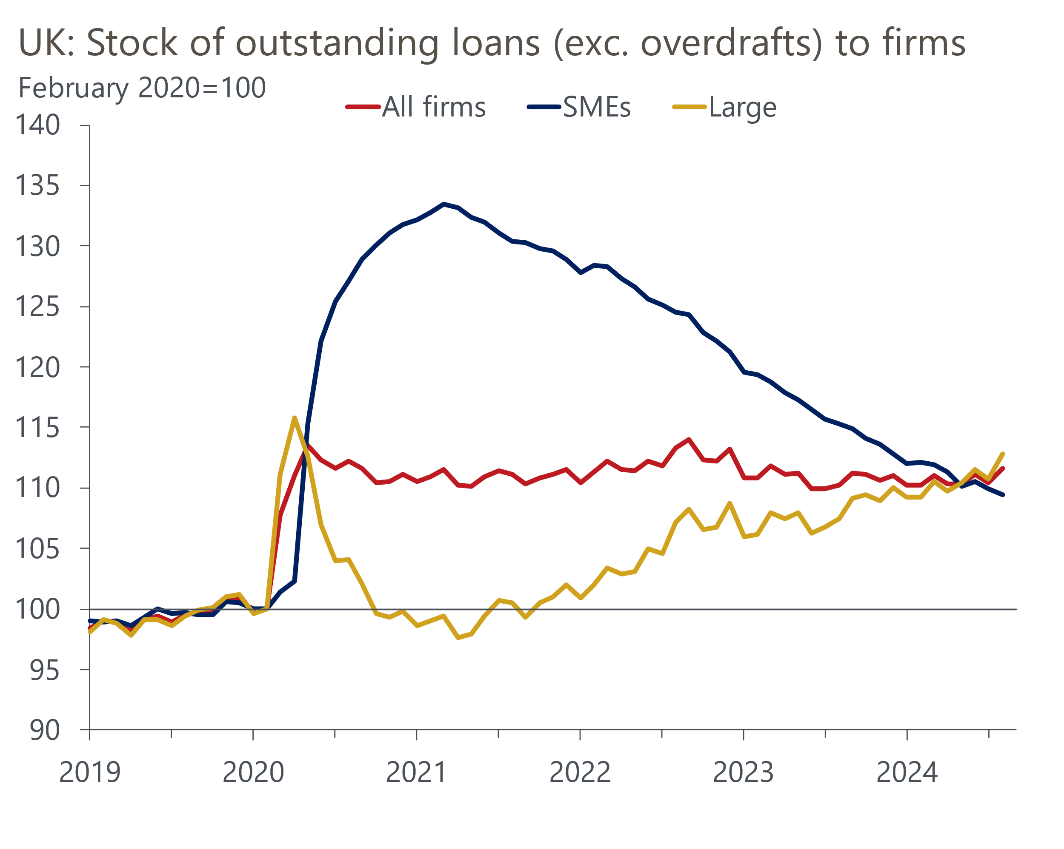
Source: Oxford Economics calculations using data from Haver Analytics
So using debt to finance investment should become increasingly attractive over the next few years. Credit availability is unlikely to be a serious constraint either. Banks haven't tightened lending standards for companies, and the latest BoE credit conditions survey reported that respondents expect lending standards for SMEs to loosen over the next three months. The survey also showed an increase in the balance of banks expecting rising investment to increase demand for loans (Chart 8).
Chart 8: Banks expect firms to borrow more to finance investment
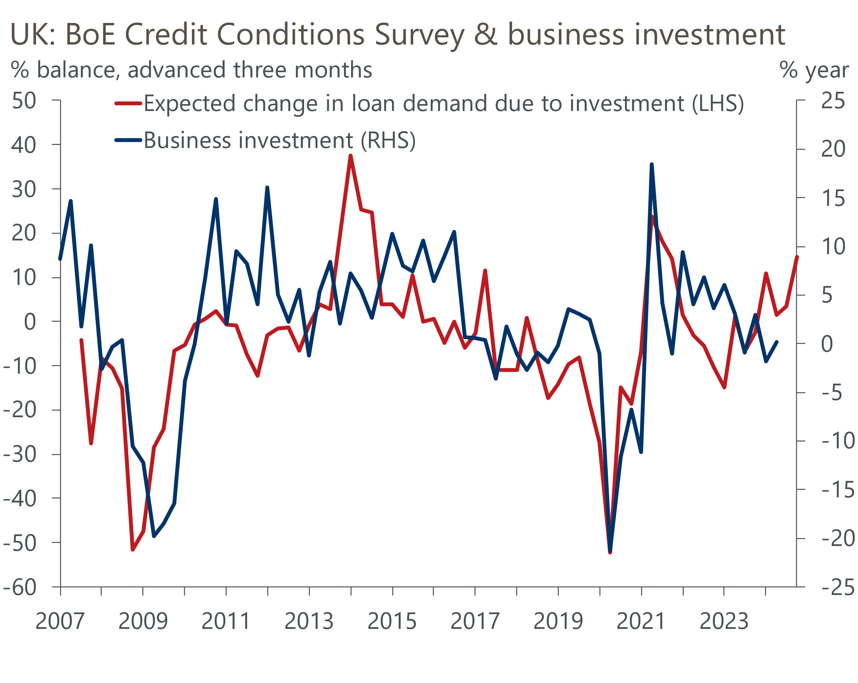
Source: Haver Analytics
The general picture for corporate finances looks more positive, too. The impact of rising interest rates on other loans had coincided with other cost pressures from rising raw material and energy prices. The rise in labour costs is easing, though it continues to run ahead of historical averages. Pressures from high raw material and energy prices have eased, however, and corporate finances appear to slowly be becoming more supportive of capital spending.

Corporate sentiment is fragile but should start to pick up
Though we expect the financial position of the corporate sector to improve, the experience of 2016-2019 – when profitability was relatively high and debt cheap – shows that strong growth in business investment doesn't necessarily follow automatically. Indeed, recent business survey data on investment intentions is still relatively weak, and the historical relationship suggests business investment is likely to remain flat over the next six months (Chart 9).
Chart 9: Business surveys point to investment remaining flat in the near-term
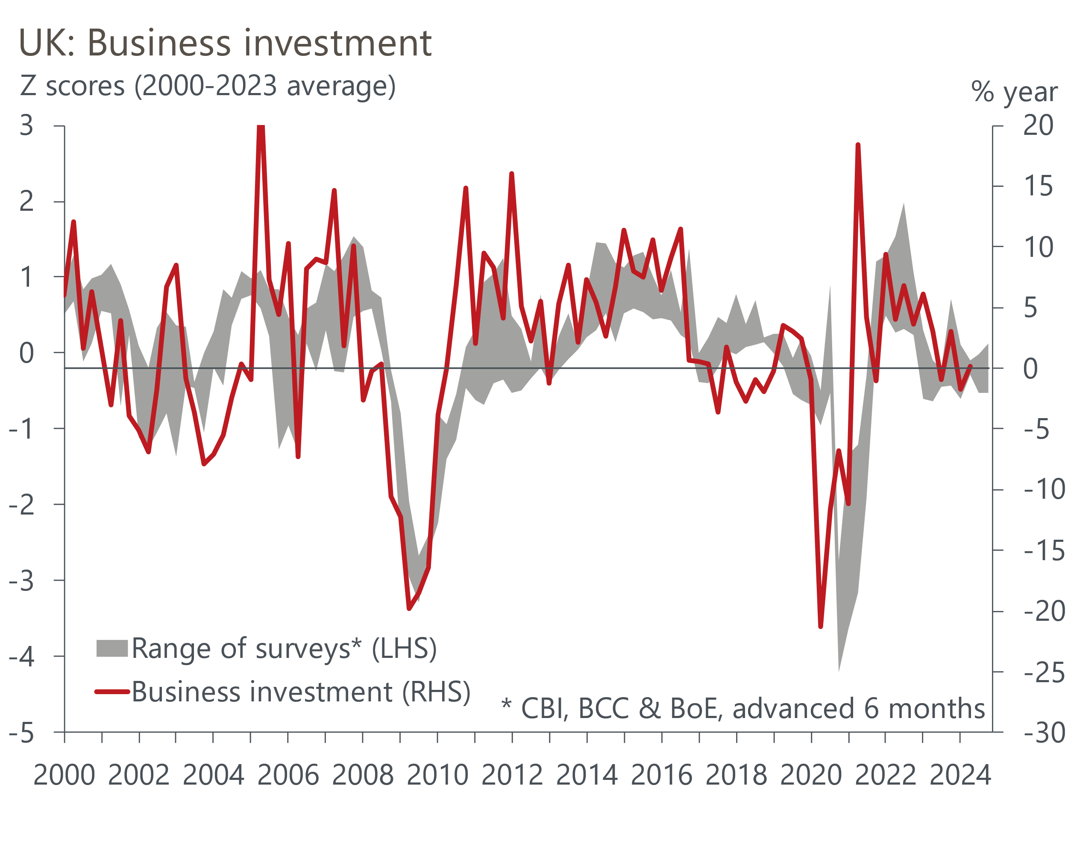
Source: Oxford Economics calculations using data from Haver Analytics
But the surveys also tell us the cost of finance and a shortage of internal finance are key reasons why firms have not been investing, so brighter prospects for both should mean that investment intentions begin to firm soon.
Government also has a role to play. The previous administration introduced full expensing – the permanent successor to the super-deduction – offering 100% capital allowances. Though the impact of the super-deduction was modest, partly due to its relatively narrow focus, full expensing should continue to offer some support to capital spending.
It seems unlikely that the new Labour government will add to this support in the upcoming Budget, given that its focus is largely on state-funded investment. But the government could still help firms if it can provide a more stable political climate and implement growth-friendly policies. Under the Conservatives, frequent changes of Prime Minister and Chancellor, and associated swings in policy priorities, made business planning more challenging, particularly considering the disruption already caused by Brexit and the pandemic. International perceptions of the UK as a place to do business have also suffered in this period, so the change of government provides the opportunity for a reset.
In particular, the new administration's overhaul of the planning system, if implemented well, could help to reverse the long-running slump in buildings investment. Pursuing a more constructive relationship with the European Union, with a view to chipping away at some of the trade barriers erected by Brexit, could also help investment in export-intensive sectors.

A gradual recovery in capital spending looks likely
At this stage, though, we regard government-led measures to improve the investment climate as upside risks rather than baseline assumptions. We think the most likely outcome is a gradual pickup in business investment growth as profitability recovers and debt servicing costs drop back (Chart 1).
Still, even if we're right, the UK would remain in the lower half of the G7 league table in terms of business investment performance since the start of the pandemic (Chart 10), and well behind its more dynamic US peer. This also implies that the UK's productivity performance will continue to disappoint.
Chart 10: We expect UK business investment growth to lag countries like the US
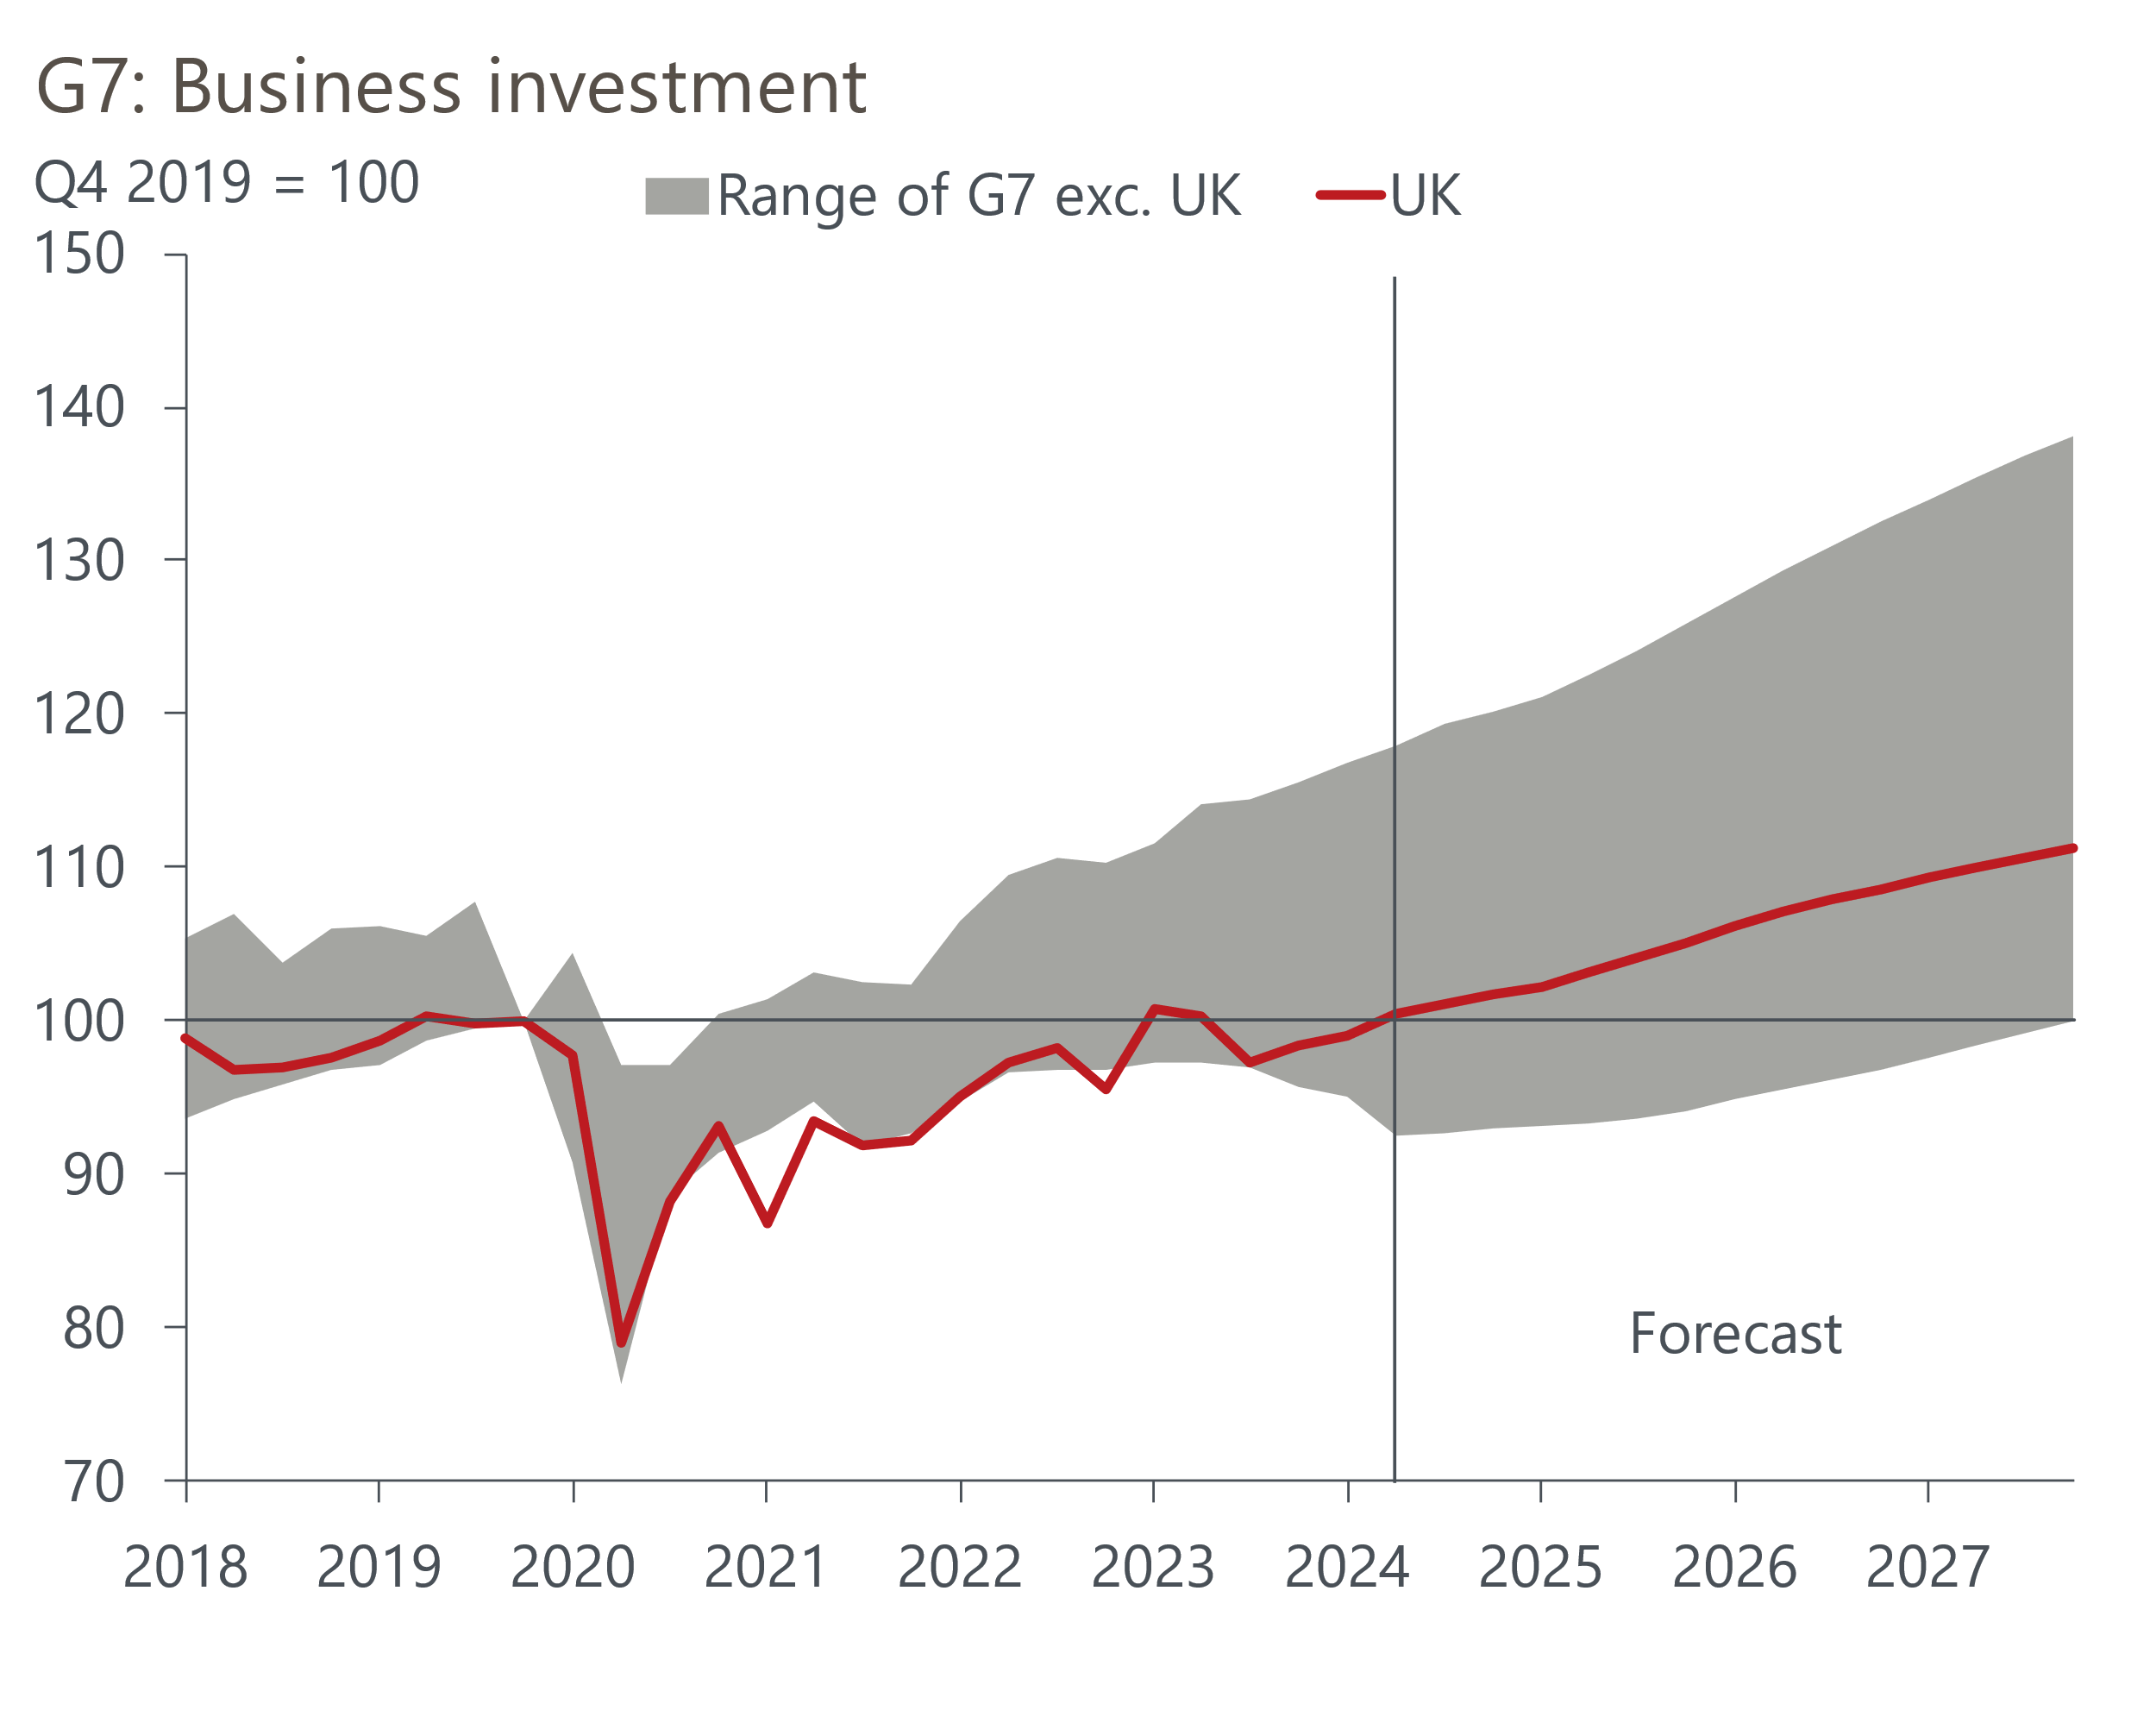
Sources: Oxford Economics, Haver Analytics

